Communication Title (Calibri light, 18 pts, bold, blue, accentuation 5, left align, single line spacing, 36 pts before and after)
First name NAME (Style ‘Name’: Calibri, 11 pts, left align, single line spacing, 6 pts after)
Author's affiliation (Style ‘Affiliation’ : Calibri, 11 pts, light gray 50%, left align, single line spacing, 6 pts after)
Full postal adress ;
Electronic.adress@organization.org
Acknowledgement (Acknowledgement style: Calibri, 9 pts, italic, justified, single spaced, 6 pts before, 12 pts after).
Objective – The authors are invited to write an English version of the paper abstract. The length of this abstract should not exceed 10 lines. The abstract should be divided into 3 parts: Objective: presenting in a synthetic way the objectives of the proposed work ;
Findings – presenting the main results ;
Originality – emphasizing the original features of the work. (Abstract style: Calibri, 10 pts, bold, justified, single spaced, 12 pts before, 12 pts after).
Keywords - Write a list here of no more than 8 significant keywords. (Keyword style: Calibri, 10 pts, single spaced, 12 pts before, 24 pts after).

Introduction
Describe the context and objectives of the work. Position the work in relation to the literature and the main previous works. Present the plan of the paper. (Style 'BodyArticle': Times new roman, 10 pts, justified, single spaced, 2 pts before, 4 pts after).

Section 1
Develop in sections, sub-sections and sub-sub-sections (not exceeding 3 hierarchical levels) the work carried out, presenting the main steps and results and emphasizing the most original and difficult to understand aspects. The text of the abstract should be between 2 and 4 pages and should follow the format described in this document. The preferred language is English. The full submission should extend to between 6 and 8 pages.
Tables, figures and equations should be numbered and formatted as follows. Figures and tables should be centered and preferably placed at the top or bottom of the page. Equations should be numbered, and a line may be left free before and after each equation to improve readability where necessary.

Table 1. Table title (Style ‘Legende’ : Calibri, 9 pts, bold, justified, single line spacing, 6 pts before, 6 pts after)

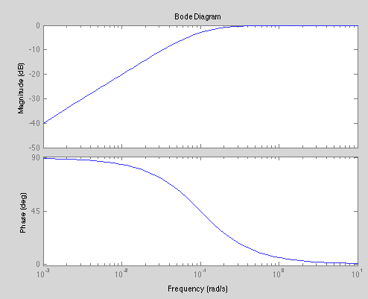
Figure 1 : figure title (Style ‘Legende’ : Calibri, 9 pts, bold, justified, single line spacing, 6 pts before, 6 pts after)

(1)

Sub-section title (Style ‘Title 2’ : Calibri, 12 pts, justified, single line spacing, 12 pts before, 12 pts after, 2nd level hierarchy type 1.1.1...)
Lorem ipsum dolor sit amet, consectetur adipiscing elit. Sed dapibus molestie nibh, id gravida diam ultrices at. Nulla facilisi. Nunc gravida, tellus in hendrerit lobortis, ex diam rhoncus eros, non elementum elit nisi vel ipsum. Maecenas lorem lorem, porttitor sit amet tempus eget, eleifend id purus. Vestibulum rhoncus lorem eu mollis venenatis.. (Style ‘CorpsArticle’)

Sub-sub-section title (Style ‘Title 3’ : Calibri, 11 pts, justified, single line spacing, 12 pts before, 6 pts after, 3rd level hierarchy type 1.1.1...)
Mauris felis turpis, laoreet sit amet leo a, aliquet porta mauris. Mauris dui dui, malesuada et iaculis vel, auctor ac libero. Integer velit sapien, rutrum vitae nisl at, dictum euismod diam. Ut purus justo, efficitur quis faucibus vel, faucibus vel quam. Phasellus posuere erat posuere lorem tristique blandit. (Style ‘CorpsArticle’)

Submission
Submission is made online from the conference website https://sates-2023.sciencesconf.org under the heading "Submission".) The site includes a paper deposit management system, which requires the creation of an account.
The submitted file will first be converted to PDF format with embedded fonts and should not exceed the maximum size of 10 MB.

Conclusion
Summarize the main outstanding and original results of the work. If necessary, propose perspectives for the work presented.

Bibliography (Title 1 without number)
Cite here the main references of the work done. Give preference to the most relevant references and original publications. Use normal style and number the references as in the example below - in order of appearance in the text.
- T.M. Jahns, “Torque Production in Permanent Magnet Synchronous Motor Drives with Rectangular Current Excitation”, IEEE Trans. Ind. Appl., Vol. IA-20, pp. 803-813, (1984).
- B. Heller, and V. Hamata, “Harmonic Field Effects in Induction Machines”, New York, Elsevier, (1977).

